Don’t Think Twice – 92 Min (Albert Morell + Jill Lummus) Feb 24

Don’t Think Twice is a smart, funny, and honest comedy about a six-person comedy team, known as The Commune, that has killed onstage for 11 years, waiting for its big break. When one of the group becomes a solo success, the movie explores the feelings and reactions of others, including envy, anger, a sense of loss and self-doubt.
Learning objectives:
- Participants will understand how humor, wit, comic timing, and laughter provide pleasure by playing on our defenses against aggression, misfortune, pain, and humiliation.
- Participants will understand, through the film, how to examine the effects of envy on group dynamics when humor fails, and apply that to clinical situations
- Participants will apply Freud’s concept of mourning to explore the loss of a dream as illustrated in the film.
Albert Morell, Ph.D., is a Lacanian clinical and research analyst in private and institutional practice. He is a former university lecturer in literature, philosophy and film studies, as well as a former screenwriter. He is co-editor of The Los Angeles Psychologist, and is founder and delegate of the California Forum of the Internationale des Forums École de Psychoanalyse des Forums du Champ Lacanien (IF-EPFCL), based in Paris, France.

Jill Lummus, PsyD, an Advanced Clinical Associate at NCP, and on the faculty of their Psychoanalytic Psychotherapy Program, where she teaches courses on Gender & Sexuality, and Psychosis. She has a Masters of Fine Art in Acting from Rutgers University. In 2012, she was the first recipient of the Elyn Saks Scholarship for work with patients with psychotic states of mind.
A Tale of Love & Darkness – 93 Min (Dahlia N Russ + Miriam Tasini) March 24
A Tale of Love and Darkness follows the story of a son's relationship with his mother and her suicide. Set during the end of the British Mandate for Palestine and the early years of the State of Israel, the film details the young man's experiences growing up during a time of war, his becoming a writer, and looking at what happens when the stories we tell, become the stories we live.
Learning Objectives:
- Attendees will learn how to trace the effects of early life events on development of depression and marital difficulties.
- Attendees will understand the influence of parental suicide on children in their adolescence, and how that affects their subsequent life decisions
Dahlia Nissan Russ, PsyD, LCSW, is a psychoanalyst and an active faculty member of the New Center for Psychoanalysis. Currently she chairs the NCP Curriculum Committee. She is also Chair of The Leonard J. Comess Israel Teaching Fund. Dr. Nissan Russ has maintained a clinical practice for the past 22 years in West Los Angeles treating young adults, adults and couples.
Miriam Tasini, MD is a Professor of Psychiatry at UCLA, a Training and Supervising Analyst at the New Center for Psychoanalysis and an honorary member of the Polish Psychoanalytic society. She studied the Holocaust and problems of restitution as she wrote a book Where Are We Going? (2008) about her family’s survival as they escaped half way around the world.
In The Mood for Love – 92 Min (Pranav Shah + Afsaneh Alisobhani) April 7
In the Mood for Love is a tender love story about love itself. Set in Hong Kong and South-East Asia in the 1960s, it follows the connection and tensions between two neighbors whose paths cross often, but whose intentions rarely do.
Learning Objectives:
- Utilize their learning of the effects of Superego and its relationship to the social norms and ideals to the clinical situations.
- Understand the relationship between regret and revenge, and how that plays out in the lives of their patients.
Pranav Shah, M.D. is a psychiatrist and a psychoanalytic psychotherapist who is passionate about movies and their use in illustrating the fundamental principles of psychoanalysis. He has co-authored a psychoanalytic study of the films of the renowned Indian auteur, Satyajit Ray.

Afsaneh Alisobhani, PsyD is a training and supervising analyst at the Newport Psychoanalytic Institute where she teaches courses on Fairbairn, Winnicott, and Bion, as well as case consultation groups. She has a private practice in Irvine, California.

April 8, Saturday Morning 9:00 – 1:30

Slavery’s Shadow: Racism in the American Psyche, Part II

A screening of two 2016 documentary films, 13th and I Am Not Your Negro, offers both formal and facilitated audience discussion of racism in the American psyche today. 13th, directed by Ava DuVernay (Selma, Queen Sugar), focuses on race in the United States criminal justice system. The film speaks to the 13th Amendment of the U.S. Constitution to outlaw slavery.
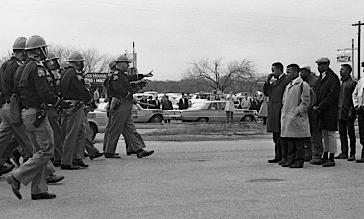
Raoul Peck's, I Am Not Your Negro, presents a political statement and probes the mind of James Baldwin, a notable 20th Century writer and social critic. It portrays both an unusual and striking cinematic biography with a specific mission of showing America through the eyes of an African-American, scattering shreds of hope amid horror, exasperation and disgust. [excerpted RogerEbert.com].

As a result of attending this course, participants should be able to
• Increase competency and insight in relating to patients/clients from diverse populations
• Explore the range of psychodynamics of racism such as projection, splitting, dehumanization, rage, resentment, and compliance/defiance
• Identify the influence of intergenerational transmission of “race” consciousness on members of diverse groups
• Recognize how film can reinforce or break racial stereotypes in the American psyche
• Apply increased awareness of racism and power dynamics in the patient and the therapist

Presenters
Veronica D. Abney, Ph.D., an ICP training and supervising analyst in private practice in Los Angeles and Santa Monica, was the 2015-16 Co-President of ICP. Her clinical expertise is in the treatment of child, adolescent and adult survivors of childhood sexual trauma. Her research interest is the history of African-American Psychoanalysts in the United States.
Jeffrey Prager, Ph.D.. is a Professor of Sociology at UCLA, former Co-Dean and a Senior Faculty Member at NCP and maintains a private practice in Beverly Hills. He has been teaching and writing on American race relations for many years, including Melancholia and the Racial Order: A Psychosocial Analysis of America's Enduring Racism presented at NCP’s Slavery’s Shadow program February 2015
Organized and Facilitated by
Thomas Brod, M.D., Co-Director of the NCP Film & Mind Series, is Associate Clinical Professor, Psychiatry, Geffen UCLA School of Medicine and Senior Faculty, New Center for Psychoanalysis. His private practice is in West Los Angeles.
Apurvah Shah, M.D., is a child and adult psychiatrist practicing in Palmdale and an Associate member of NCP. He is co-director of the NCP Film & Mind Series. He is Director and Faculty at the Antarnad Foundation (a psychoanalytic psychotherapy training program) in Ahmedabad, India.
Cafe Society – 96 Min (Debbie Lynne + Elena Balashova-Shamis) May 5
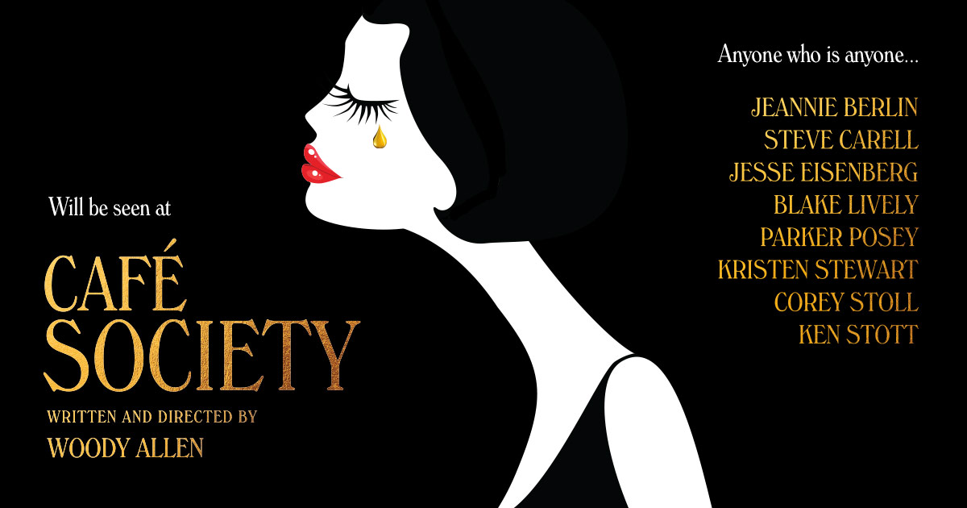

Café Society is the latest film by Woody Allen, and a lovely and enjoyable one at that. It is a movie about the arc of true love and the inevitable broken hearts in its path. It explores the nature of love, and the tensions it creates both in marriage and for marriage.

Learning objectives:

- Participants will emerge with a better understanding of the complex dynamics of courtship and marriage, and use the topics of discussion generated in their everyday practice of marriage and couples work.
- Participants will have a better understanding of the relentlessly subversive nature of love, and the defense mechanisms used by our patients, and the nature of social institutions meant to attenuate the same.

Elena Balashova-Shamis, PsyD is an advanced psychoanalytic candidate at the New Center for Psychoanalysis in both adult and child programs. She maintains a private practice in Marina Del Rey. She is a faculty member at NCP, UCLA, Ryokan College and also works as a dissertation advisor. She presents seminars and workshops on various topics in psychoanalysis, sexuality and child development.
Deborah Lynn, MD is a board certified child and adolescent psychiatrist and general psychiatrist, and psychoanalytic candidate at the New Center for Psychoanalysis. She is in private practice in Westwood as well as a member of the volunteer clinical faculty at UCLA, Department of Child and Adolescent Psychiatry.
Fire At Sea– 113 Min (Bettina Soestwohner + Apurva Shah) May 19

Fire At Sea is the first documentary to ever win the top award at the Berlin International Film Festival, FIRE AT SEA takes place in Lampedusa, a once peaceful Mediterranean island that has become a major entry point for African refugees into Europe. There, we meet Samuele, a 12-year-old boy who lives simply, climbing rocks by the shore and playing with his slingshot. Yet nearby we also witness thousands of men, women and children trying to survive the crossing from Africa in boats that are too small for such a journey. Filmmaker Gianfranco Rosi masterfully places these realities side by side, and in so doing creates a remarkable third narrative that jolts us into a new understanding of what is really happening in the Mediterranean today.
See Also:
http://variety.com/2017/film/global/fire-at-sea-director-gianfranco-rosi-on-meryl-streep-and-the-refugees-crisis-1201991223/
Trailer:
https://www.youtube.com/watch?v=gFuE5sjGG7U

Learning Objectives

- To understand the effects of colonization and “modernization” on the culture and psyche of indigenous people and the destructive hierarchy it creates both socially and intra-psychically, and discuss how that is manifested clinically.
- To discuss the concept of jouissance and its relationship to the impact on the current refugee crisis and intrapsychically with our patient population.

Bettina Soestwohner, PhD, PsyD holds a doctoral degree in Comparative Literature from UC Irvine. She is a Graduate Research Psychoanalyst and faculty member at the New Center for Psychoanalysis and a Training and Supervising Analyst at the Newport Psychoanalytic Institute. She is a member of the California Circle of the EFQ (Freudian School of Quebec) and of the IFLF (International Forums of the Lacanian Field.) She has a private practice in Los Angeles.

Apurva Shah, MD is a child and adolescent psychiatrist working for Kaiser Permanente in Palmdale. An Associate member of the New Center for Psychoanalysis, he is the co-coordinator of the Film and Mind Series. He is also the Founding Director and Faculty at the Antarnad Foundation, a not-for-profit psychoanalytic psychotherapy training program, in Ahmedabad, India.

Demolition – 100 Min (Tom Brod + Sandra Cohen) June 2
Demolition is a stylish and non-violent film, dream-like in its naked (and over-determined) story-lines and disguises against feelings of grief and emotional disconnectedness.
Learning Objectives
- Participants will distinguish between normal grieving and pathological reactions to loss in their patients.
- Participants will understand that proper mourning in their patients does not involve active attempts to abolish the past.
- Participants will learn that normal grieving necessities an empathic witness to go through all the reactions and memories involved in a loss step by step.
- Participants will identify emotional deadness as a malignant defense against grief in their patients and clients.
Thomas Brod, MD, Distinguished Life Fellow of the American Psychiatric Association, is an Associate Clinical Professor of Psychiatry at the UCLA Geffen School of Medicine. He is a senior faculty member at NCP and the co-coordinator of the Film and Mind Series. He is also on the faculty of the ISTDP Institute (Washington DC).

Sandra E. Cohen, Ph.D., is a Training and Supervising Analyst at the Psychoanalytic Center of California and in private psychoanalytic practice in Beverly Hills with adults and teenagers. Her areas of specialization include early trauma, sexual abuse, perversions, psychotic and borderline disorders, dissociative states, self-mutilation (cutting), and pathological defensive organizations. Through her blog Characters on the Couch (www.sandracohenphd.com), Dr. Cohen uses her clinical experience to analyze the fictional characters in film, television and books.
Swiss Army Man – 97 min (Luis Nagy + Josh Richmond) June 9
Swiss Army Man is a surreal drama about a man stranded alone on a deserted island who makes one last attempt at escape after an unusual dead body washes up on shore. The talking corpse provides the castaway with a number of unexpected tools, which he'll need if he wants to be reunited with his love.
Learning Objectives
- Understand the role of repression as a protective and / or harmful mechanism.
- Identify isolation and its role in preventing the self from harmful thoughts or feelings and how it relates to manic states.
- Discuss and analyze the homosexual tension between Hank and Manny.
Luis Nagy PhD is psychoanalyst who practices in Mexico City and Alhambra, California. He is a Training & Supervising Analyst with Sociedad Psicoanalitica de Mexico and an Associate Member of NCP. With a special interest in films and communication, he is an Editorial Board Member of the IPA website; he is Spanish Editor of International Psychoanalysis Net. Additionally, he is Full Professor at the Institute of Post-degree Studies in Psychoanalysis and Psychotherapy.

Joshua Richmond is a vested member of the Writers Guild of America West and has written for film and television for over twenty years, writing scripts for Ron Howard, Universal, Disney etc., and has created TV shows for Fox and Disney. Currently he teaches screenwriting and sitcom writing at Cal State Fullerton and is a psychoanalytic studies candidate at the New Center for Psychoanalysis.
Mustang – 97 Min (Joan Lachkar + Shahin Sakhi) June 23
Mustang is a fresh-spirited, sad, uplifting, culturally honest and remarkably entertaining film about five modern sisters in rural Turkey whose family wishes to hold them in ancient religious bindings. It offers a great insight into psychological issues, both universal and cultural, especially those that affect the character development and gender identity of pre-teen and teenage girls.
Learning Objectives
- To explore and determine what is culturally healthy vs what is abusive, vis a vis cultural differences; and how to deal with this often fine line in our rapidly changing and culturally diverse patient population.
- To study the ever-changing cultural gender roles in society and discuss its application in clinical practice
Discussants:
Joan Lachkar, Ph.D., is a licensed Marriage and Family therapist in private practice in Sherman Oaks, California, who teaches and practices psychotherapy using a psychodynamic approach. She is the author of five books and numerous publications on marital and political conflict.
Shahin Sakhi, M.D., Ph.D. is an Assistant Clinical Professor at UCLA, candidate in psychoanalytic training at NCP, and in private practice in West Los Angeles. He is a certified consultant from the AK Rice Institute for the Study of Social Systems.

