ISTDP Institute

And

Washington School of Psychiatry
Present
Summer School for Psychotherapists
Five Days of Intensive Psychotherapy Training + Immersion Experience
21.75 Continuing Education Hours
Captain Whidbey Inn
Whidbey Island WA
Puget Sound, Pacific Northwest
August 13-18, 2017
(Sunday dinner- Friday noon meal)

With

Thomas M. Brod, MD, Robin L. Kay, PhD

Nat Kuhn, MD, Tony Rousmaniere, PhD

brochure contents
Summer School Description page 2-4
Schedule 5-6
Continuing Education/Objectives 6-8
Faculty and Sponsors 8-11
Fees 11-12
Transportation Planning 12-16
Contact Information 16
Registration Info 16-17
REGISTRATION FORM 18-20
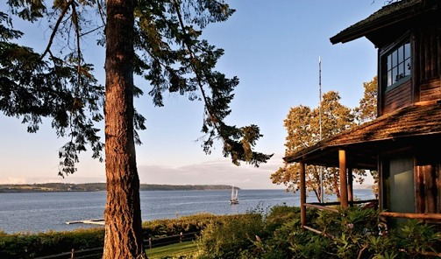
_________

Whidbey Island ISTDP Summer School
The Whidbey Island Summer School is meant for practicing psychotherapists at all levels who wish to deepen their understanding, competence, and comfort with the theory and practice of intensive psychodynamic psychotherapy. 2017 will be the third summer this immersive learning experience has been offered.

Experiential Dynamic Psychotherapy (EDT) and Intensive Short-Term Dynamic Psychotherapy (ISTDP) represent a unique form of affect/body/relationship-based psychodynamic treatment that facilitates the rapid resolution of a broad spectrum of emotional disorders. It is an evidence-based psychotherapy developed by Habib Davanloo, MD, strongly supported by extensive clinical research studies. EDT/ISTDP interventions are specifically designed to resolve anxiety, depression, somatization and personality disorders, as well as, to alleviate a variety of self-defeating behaviors, many of which derive from unstable or troubled early life attachments.
Physicians, psychologists, licensed therapists, nurses, and social workers can earn 21 Continuing Education hours through Washington School of Psychiatry (see page 6).

Two Tracks: Foundational and Advanced
At its heart, this Summer School is designed to bring experienced psychotherapy clinicians into increased competence and comfort with the work of Experiential Dynamic Psychotherapy and ISTDP. The program will be arranged around two tracks, but much study will be together as a single group. The faculty will use video vignettes and role-playing with participants. Large group processing will be emphasized for supervision, role-playing, and processing of unconscious activation
The Foundational Track is built as a primer on ISTDP for physicians, psychologists, and other mature psychotherapists ready for foundational work in this revolutionary dynamic treatment. The primer will cover aspects of ISTDP that are key to understanding its practice, such as our emotions and defense mechanisms, video recordings of sessions, the cost effectiveness of ISTDP etc. Additional topics include the research evidence of success of short-term therapies in wide-ranging conditions like panic disorder, somatization disorder, anxiety, depression, medically unexplained symptoms and personality disorders.
Psychotherapists who have had at least one year in an EDT/ISTDP core-training group, can join the Advanced Track with the opportunity for close study of faculty videotapes, supervision, and work on skill-building exercises.
Both tracks offer deepened understanding of ISTDP theory and technique. All participants in the Summer School will join together in skill-building and large group processing throughout the week and will be introduced to Deliberate Practice. Even participants with significant prior ISTDP exposure have found this systematic approach helpful.

Description of the Summer School

As in prior years, the Summer School will occupy the full facility of the historic 100 year-old Captain Whidbey Inn for this five-day intensive program. The Inn is located on Whidbey Island, on Puget Sound, outside of Seattle.
The curriculum includes didactics, skill-building exercises including role-playing, and group processing of unconscious activation; for those who are interested, there are opportunities for individual supervision of recorded material with the rest of the group observing.
Recreational opportunities are scheduled.
Enrollment will be strictly limited to 25 or fewer Professional learners. Accommodations can be made for accompanying adults who do not attend the program.
The didactic material will focus on principles and techniques of Intensive Short-Term Dynamic Psychotherapy, and will include extensive video vignettes. Topics to be covered will include establishing an internal emotional focus for treatment, helping patients track emotional causality of anxious/somatic experiences, managing multiple layers of projection, and focusing on the transformative power of the Unconscious Therapeutic Alliance (UTA) in the processing of guilt and forgiveness, among others. Skills of Deliberate Practice will be emphasized.

2017 Summer School Program Tentative Schedule
21.75 hours CE/CME

Sunday, August 13 Arrival and registration
3-4:30 pm Welcome, Introductions and Clinical Video
4:30-5:45 Two Tracks—Developing and Maintaining an Effective Intrapsychic Focus
6:30 Dinner
7:30-8:30+ Welcoming Gathering for All
Sunset 8:23

Monday, August 14 Sunrise 6:05

7 -7:30 Yoga/XiGong (optional)

9-10:30 (ALL) Faculty video

11-1 Two Tracks, continued
1-2 Lunch
2-4 Two Tracks, continued
4-5 ALL: Skill Building Practice
5-5:30 ALL: Group process
5:30 – 6 Dance/Sing Along
6:30 Dinner
Sunset 8:19

Tuesday, August 14 Sunrise 6:06

7 -7:30 Yoga/XiGong (optional)

9-10:30 (ALL) Faculty video
11-1 Two Tracks, continued
1-2 Lunch
2-4 Two Tracks, continued
4-5 ALL: Skill Building Practice
5-5:30 ALL: Group process
5:30 – 6 Dance/Sing Along
6:30 Dinner
Sunset 8:10
Wednesday, Aug 16 Sunrise 6:08
9-10:30 (ALL) Faculty video
11-12:30 Group Supervision
12:30-1 Lunch

1-6 Play day: go for a hike, biking, kayaking, whale watching, or swim.
6:30 Dinner
8:17 Sunset

Thursday, Aug 17 Sunrise 6:09

7 -7:30 Yoga/XiGong (optional)

9-1 (ALL) Deliberate Practice
1-2 Lunch
2-5 Deliberate Practice
4-5 ALL: Skill Building Practice
5-5:30 ALL: Group process
5:30 – 6 Dance/Sing Along
6:30 Dinner
8:17 Sunset

Friday, Aug 18 Sunrise 6:10
9-11 Skill Building/Deliberate Practice
11-12 Group Process and Goodbye
Afternoon departure.
______________________________________________

Learning Objectives
At the conclusion of the Summer School participants should be able to:
- Apply at least two techniques that build capacity to tolerate anxiety;
- Recognize and apply pressure to increase intrapsychic crisis;
- Apply several forms of pressure and use patient’s level of anxiety to determine threshold of tolerable pressure;
- List three discharge pathways of unconscious anxiety as described by Davanloo;
- Identify the unconscious guilty need for punishment and self- sabotage in patients/clients and help them free themselves from the resultant symptoms;
- Recognize resistance to emotional closeness and its the relationship to primal attachment; Understand and apply respect for the patient/client while helping them turn against their defenses against emotional closeness;
- Understand and apply respect for the patient/client while helping them turn against their defenses against emotional closeness;
- Describe Malan’s triangles and their role in psychotherapy;
- Understand and apply the Triangle of Conflict in the management of symptoms;
- Learn to differentiate Defenses from Anxiety from Disowned Feelings;
- Learn to deactivate identification with defenses;
- Recognize the inverse relationship between unconscious Resistance and the Unconscious Therapeutic Alliance;
- Differentiate Conscious from Unconscious Therapeutic Alliance and recognize how each contributes to therapeutic success;
- Define an “unlocking” of the unconscious, and describe the role of experiencing unconscious guilt in unlocking the unconscious;
- Recognize and give examples of how the unconscious therapeutic alliance functions in ISTDP;
- Learn to maintain focus on transference;
- Manage multiple dimensions of the transference resistance;
- Identify and deactivate identification with the resistance;
- Identify and deactivate the omnipotent transference;
- Recognize projection of authority and respond therapeutically;
- Recognize activation of your own unconscious;
- Describe the difference between the phase of repeated unlockings and the phase of working through;
- Identify “fragility of ego structure” and apply techniques to build structure;
- identify which of the three types of defensive structure is dominating in each clinical moment;
- Recognize when thresholds of anxiety tolerance have been reached;
- Determine Specific ISTDP Skills for Deliberate Practice
- Learn techniques of self-supervision through systematic video review
- Set up systematic Deliberate Practice of specific ISTDP skills.
- Observe colleagues’ sessions by video and learn effective clinical interventions;
- Experience and observe the play of unconscious dynamic forces within your own self.

21.75 Certified Continuing Education hours will provided through the Washington School of Psychiatry. IMPORTANT DISCLOSURE INFORMATION FOR ALL LEARNERS: None of the planners and presenters of this CME program have any relevant financial relationships to disclose. The activity is coordinated and funded by Thomas M Brod, and designed to be a not-for-profit activity.
Physicians: This activity has been planned and implemented in accordance with the accreditation requirements and policies of the Accreditation Council for Continuing Medical Education (ACCME) The Washington School of Psychiatry designates this Live Activity for the maximum of 21.75 hours of AMA PRA Category 1 Credit(s)™. Physicians should claim only the credit commensurate with the extent of their participation in the activity.
Psychologists: The Washington School of Psychiatry is approved by the American Psychological Association to sponsor continuing education for psychologists. New Center for Psychoanalysis maintains responsibility for this program and its content. Full attendance is required for psychologists to receive credit; partial credit may not be awarded based on APA guidelines. For the psychologists’ records, certificates of attendance are provided at the completion of the course
Social Workers and Family Therapists, LCSW, LMFT, ASW, IMF, LEP, LPCC, PCCI :The Washington School of Psychiatry is a continuing education provider that has been approved by the American Psychological Association, a Board of Behavioral Sciences recognized approval agency.
Registered Nurses: The Washington School of Psychiatry is an accredited provider approved by the California Board of Registered Nursing (Provider #CEP1112). Registered Nurses may claim only the actual number of hours spent in the educational activity for credit.

FACULTY

Coordinator: Thomas Brod, MD
Thomas M Brod, M.D. graduated from the University of California, Berkeley and received his medical degree from the University of Southern California. After serving in the Indian Health Service of the U.S. Public Health Service, he was selected into the National Institute of Mental Health Career Development Program, and was sponsored by NIMH during his residency and fellowship at UCLA Neuropsychiatric Institute (Psychiatry).
Trained in classical and contemporary psychoanalytic models, and Intensive Short-Term Dynamic Psychotherapy, Dr. Brod is a graduate of the Los Angeles Psychoanalytic Institute. He trained in ISTDP with Robert Neborsky, Patricia Coughlin, and Josette Ten Have-de Labije—but predominantly under Habab Davanloo in Montreal since 2001. He is also an Associate Clinical Professor of Psychiatry at UCLA. Certified by the American Board of Psychiatry & Neurology, he is a Distinguished Life Fellow of the American Psychiatric Association, Senior Fellow of the Biofeedback Certifying Institute of America, and maintains professional memberships in national and local societies for medicine, psychiatry, psychoanalysis, hypnosis, biofeedback and neurofeedback. He is a certified instructor and supervisor of the International Experiential Dynamic Psychotherapy Association (IETDA), and is on the faculty of the ISTDP Institute. He has taught ISTDP on four continents. Dr. Brod is also a certified yoga instructor and a volunteer teacher at his local YMCA.

Nat Kuhn, MD
Nat Kuhn, MD is Clinical Instructor in Psychiatry at Harvard Medical School where he teaches Short-Term Dynamic Psychotherapy. He has been practicing EDT since 1996, when he joined Leigh McCullough’s Psychotherapy Research Program at Harvard’s Beth Israel Deaconess Medical Center. He worked closely with Dr. McCullough for a decade, serving as Assistant Director of the program, collaborating on the design and validation of the ATOS scale for psychotherapy coding, and serving as second author of Treating Affect Phobia: A Manual for Short-Term Dynamic Psychotherapy.
An IEDTA Certified teacher and supervisor in Dr. McCullough’s Affect Phobia Therapy (APT) model, Dr. Kuhn has taught in the US and Europe. Since 2008, Dr. Kuhn has practiced Davanloo’s ISTDP, which he has studied with Allan Abbass and Jon Frederickson. He is an IEDTA Certified teacher of ISTDP, and has a particular interest in training and dissemination of Experiential Dynamic Therapies (EDTs). His book, “Intensive Short-Term Dynamic Psychotherapy: A Reference,” (www.istdp-reference.org) was published in 2014 to wide acclaim.
In 2013, he joined the IEDTA Board of Directors and participated in organizing the 2014 IEDTA Conference in Washington, DC and the 2016 Conference in Amsterdam. As co-chair of the IEDTA’s Information Technology Committee, he spearheaded the redesign and revitalization of the IEDTA website.

He has a private practice in Belmont, Massachusetts. Before becoming a psychiatrist, Dr. Kuhn was a research mathematician; he has published work on psychotherapy, mathematics, and computational chemistry. More information is www.natkuhn.com.

Tony Rousmaniere, PhD
Dr. Rousmaniere is a psychologist in private practice in Seattle, Washington. He teaches and supervises Intensive Short-Term Dynamic Psychotherapy to therapists around the world. Dr. Rousmaniere's research focus is clinical supervision, the use of deliberate practice in clinical training, and technology for clinical supervision and training. He is the co-editor of Using Technology to Enhance Counseling Training and Supervision: A Practical Handbook, published in 2015 by the American Counseling Association Press. His new book, Deliberate Practice in Psychotherapy, has recently been published by Wiley Publishers. His next book, which he edited with Goodyear, Miller and Wampold, The Cycle of Excellence: Using Deliberate Practice to Improve Supervision and Training, will be out from Wiley Publishers in Spring 2017.
More about Dr. Rousmaniere can be found at www.drtonyr.com.

Robin L. Kay, PhD

Dr. Robin L. Kay is a licensed Clinical Psychologist with over 25 years of clinical experience. Dr. Kay maintains a private practice in Los Angeles, California where she treats individuals and couples and supervises mental health practitioners. Dr. Kay maintains an appointment as an Assistant Clinical Professor in the Department of Psychiatry and Biobehavioral Sciences at UCLA's David Geffen School of Medicine where she directs the Attachment-Based ISTDP and Accelerated Psychotherapy Clinic and has been honored for her distinguished clinical teaching. In addition, she teaches and conducts clinical training groups for mental health professionals interested in learning ISTDP and Attachment- based Short-term Dynamic Psychotherapy..

Dr. Kay obtained her undergraduate degree from the University of California at Berkeley where she was a University Merit Scholar and a recipient of a Presidential Undergraduate Fellowship. Dr. Kay graduated Summa Cum Laude from UC Berkeley and was awarded Psi Chi honors. She subsequently obtained a Masters degree and Doctorate in Clinical Psychology from the University of California, Los Angeles (UCLA). Dr. Kay has been practicing ISTDP since l998. She studied IS-TDP in the core training program of Dr. Robert Neborsky from 1998-2001. Subsequently, she studied in an advanced ISTDP training program led by Dr. Habib Davanloo. From 2002-2004, she studied Interpersonal Neurobiology and Attachment-based Mindful Parenting in Dr. Daniel J. Siegel's advanced study group. She has pursued advanced training with Allan Abbass, Josette ten Have-de Labije and other pioneers in the ISTDP community. Dr. Kay has published articles on ISTDP and teaches ISTDP internationally. She is certified as a Supervisor and Trainer by the IEDTA. More information at www.DrRobinKay.com

The ISTDP Institute
The Institute for ISTDP Training and Research is a community of people who feel a calling to alleviate human suffering to build healthier communities. We try to do this by helping people achieve their full potential through psychotherapy, psychotherapy training, and supervision. We value personal integrity, commitment to excellence, and compassion for self and others. Although the model of therapy we practice is intensive short-term dynamic psychotherapy, we are not here to “fossilize” it, but rather to co-create the integrative therapy of the future. We believe that the final answers of psychotherapy have not been found. That’s why this community is “a place that keeps the questions open.” For more information, http://istdpinstitute.com
The Washington School of Psychiatry (District of Columbia)
Celebrating its 80th year, the School is an accredited provider of post-graduate continuing education. The Washington School of Psychiatry is an independent non-profit organization. It is not affiliated with the government of the District of Columbia or the government of the United States. For more information washschool@wspdc.org

Fees and Arrangements
The enrollment fee covers tuition, room, all meals (Sunday dinner– Friday lunch), and the continuing education certificate.
Transportation, alcoholic beverages, and optional recreational activities are not included.
Our summer school will be filling the entire Captain Whidbey Inn. Fee is either $2000 or $2550 depending on your room choice. Please be advised that the historic inn is over 100 years old, and the rooms are small with thin walls but well furnished.
You can choose to stay in the Inn itself in a private room with bathroom down the hall. Alternatively, (for early-birds) we have a five sharable rooms each with its own bathroom in the motel-style Lagoon Building a few steps away. Both options (shared room and private bath; private room/hallway-shared bath) are $2000.
A few private rooms with bath in the Lagoon Building are available for $2550. If you are accompanied by another adult not participating in the program, who would share your (queen-size) bed, the extra charge is $950.
Space is limited, and preference in room assignment will go those who register earliest.
To register, please fill out and return the registration form at the end of this document with your payment.
Please note that because this Summer School is designed as not-for-profit, fees have already been cut to the lowest possible point. Unfortunately, we are not able to offer discounts for residents or students.
A $500 deposit will reserve your place through May 31, 2017. Full payment is due by June 1, 2017. Checks in US funds should be made payable to Thomas M Brod, MD. For Credit cards (via PayPal, www.paypal.me/ThomasMBrodMD) and international bank transfer, there is a 3% service charge which we must pass on to you.
Cancellations before April 14, 2017 are subject to a 15% fee; April 15– June 14 are subject to a 50% fee. After June 14, there is no refund unless we are able to fill the space.

Planning your Journey
Note: The journey from Seattle to Captain Whidbey Inn will take a minimum of 3-4 hours (each way) so it is wise to consider flying into Seattle on Saturday Aug. 12 and traveling to Whidbey Island on or before Sunday Morning. You are headed to Coupeville, Washington.
Seattle-Tacoma Airport (SEA) is known as “Sea-Tac” for short.
Captain Whidbey Inn, 2072 West Captain Whidbey Inn Road, Coupeville, WA 98239 http://www.captainwhidbey.com

Fly, drive or take a boat! You can take a ferry from Port Townsend or Mukilteo onto Whidbey Island.
Known as the long way, one can also drive onto the island using the Deception Pass Bridge on the north end of the island. From Sea-Tac Airport you can take a shuttle bus to Coupeville, or, alternatively, shuttle to the Kenmore Air Terminal and take a floatplane that makes regular stops at the Captain Whidbey Inn.
There is only one ferry option to get to the island from SEA-TAC , the Mukilteo-Clinton ferry (see schedule, below). The SeaTac/Whidbey Island Shuttle picks up from the airport and goes directly (via ferry) to Coupeville (2 hrs,15 min). It does not have to wait in the ferry line (special privileges)*. It drops you off in the town of Coupeville. Then guests can take a taxi from Coupeville to the Inn (less than 2 miles).
note: it is possible to charter a shuttle from SeaTac Airport/Whidbey Island Shuttle and that will bring you directly to the Inn. The charge is equivalent to 12 passengers.
*For those that rent a car – in the summer – it is sometimes preferable to go by way of Deception Pass because of the possibility of a long line of cars waiting to get on the ferry. (There are websites/apps where you can check and see what the Mukilteo-Clinton ferry wait is). The Deception Pass itself drive is beautiful; however it involves a much longer drive than the ferry.

Mukilteo-Clinton Ferry Schedule
Online Shuttle Booking
www.seatacshuttle.com/scheduleRoute.php

ARRIVAL: Sea-Tac Int'l Airport to Whidbey Island (Daily)

Sea-Tac  Hotels | Sea-Tac  Airport | Coupeville
6:15 am | 6:45 am | 9:00 am
8:15 am | 8:45 am | 11:00 am
10:15 am | 10:45 am | 1:00 pm
12:15 pm | 12:45 pm | 3:00 pm
2:15 pm | 2:45 pm | 5:00 pm
4:15 pm | 4:45 pm | 7:00 pm
6:15 pm | 6:45 pm | 9:00 pm
8:15 pm | 8:45 pm | 11:00 pm
10:15 pm | 10:45 pm | 1:00 am

RETURN: Whidbey Island to Sea-Tac Int'l Airport (Daily)
Coupeville | Sea-Tac  Airport | Sea-Tac  Hotels
-- | 4:30 am | 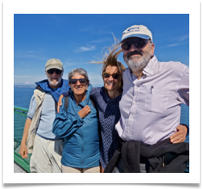  4:45 am
4:30 am | 6:30 am | 6:45 am
6:30 am | 8:30 am | 8:45 am
8:30 am | 10:30 am | 10:45 am
10:30 am | 12:30 pm | 12:45 pm
12:30 pm | 2:30 pm | 2:45 pm
2:30 pm | 5:00 pm | 5:15 pm
5:30 pm | 7:30 pm | 7:45 pm
7:30 pm | 9:30 pm | 9:45 pm

Fares to/from Sea-Tac Airport
 |  | Adult | Military | Senior | Youth
Coupeville | One-way  Round-trip | $41.00  $78.00 | $39.00  $74.00 | $39.00  $74.00 | $25.50  $51.00

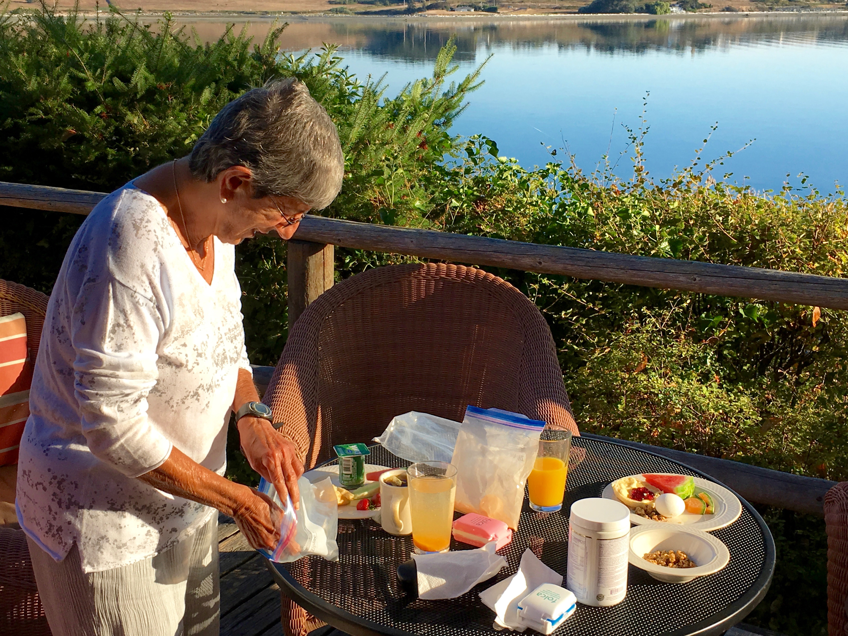

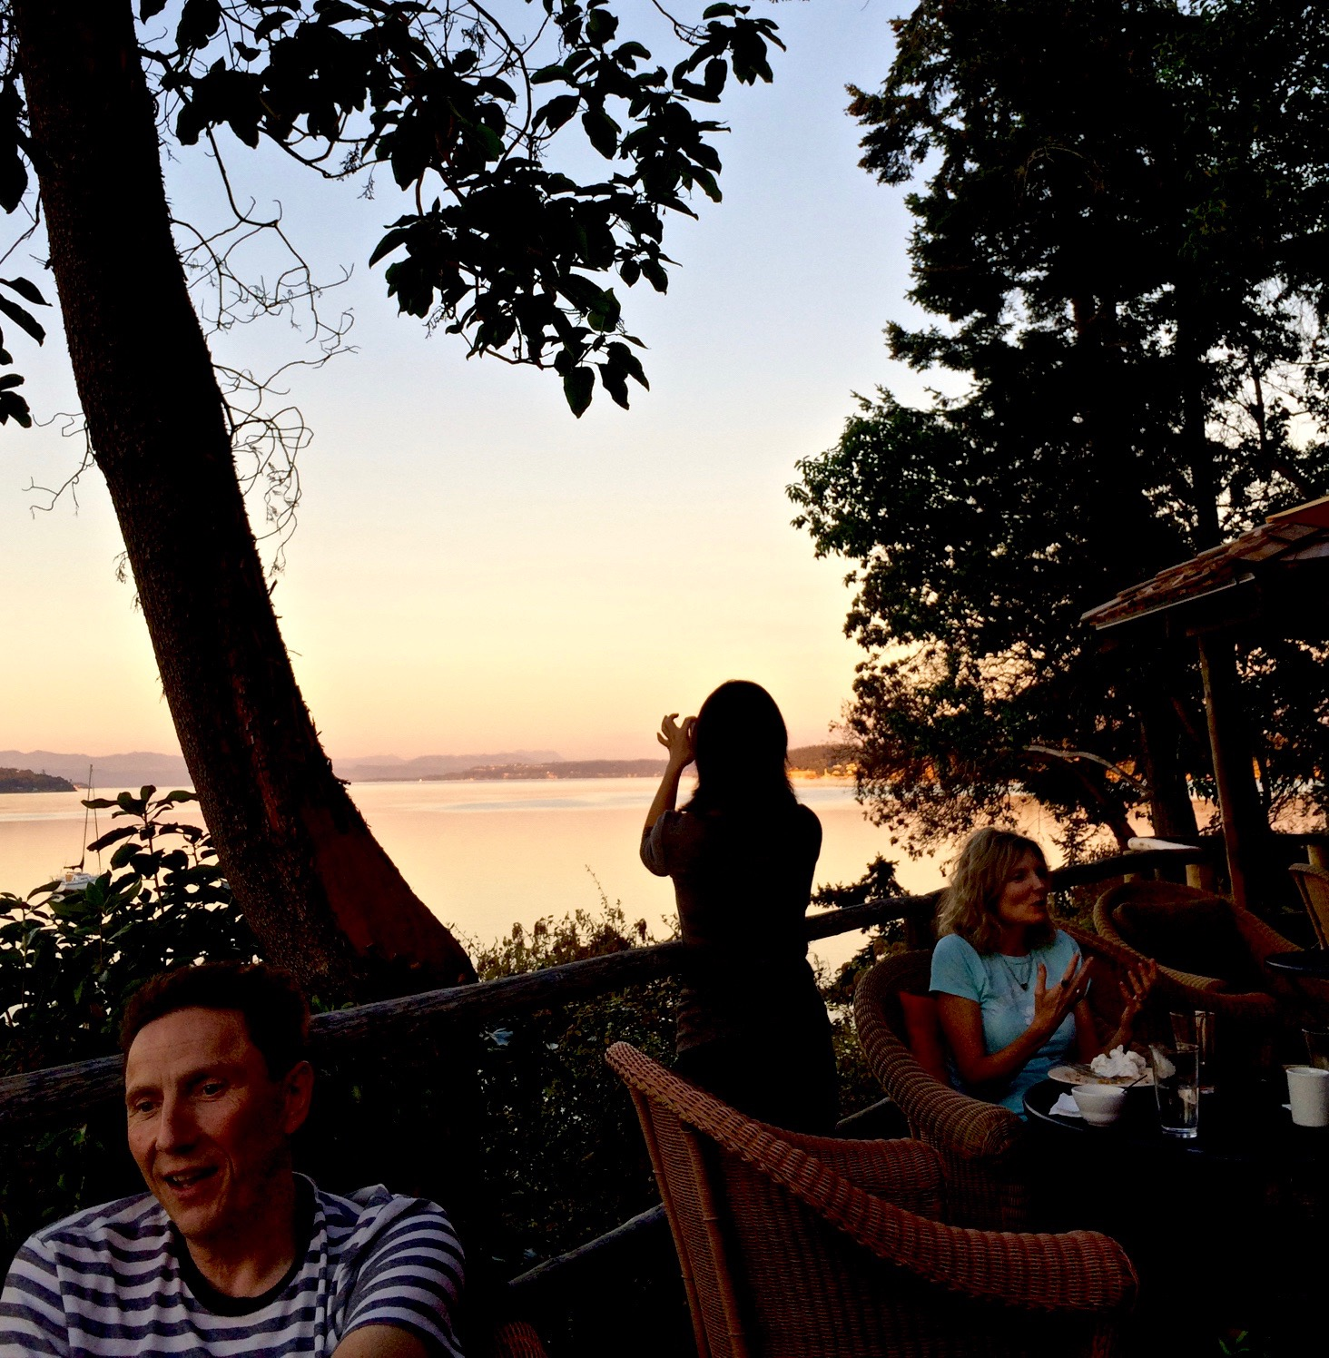
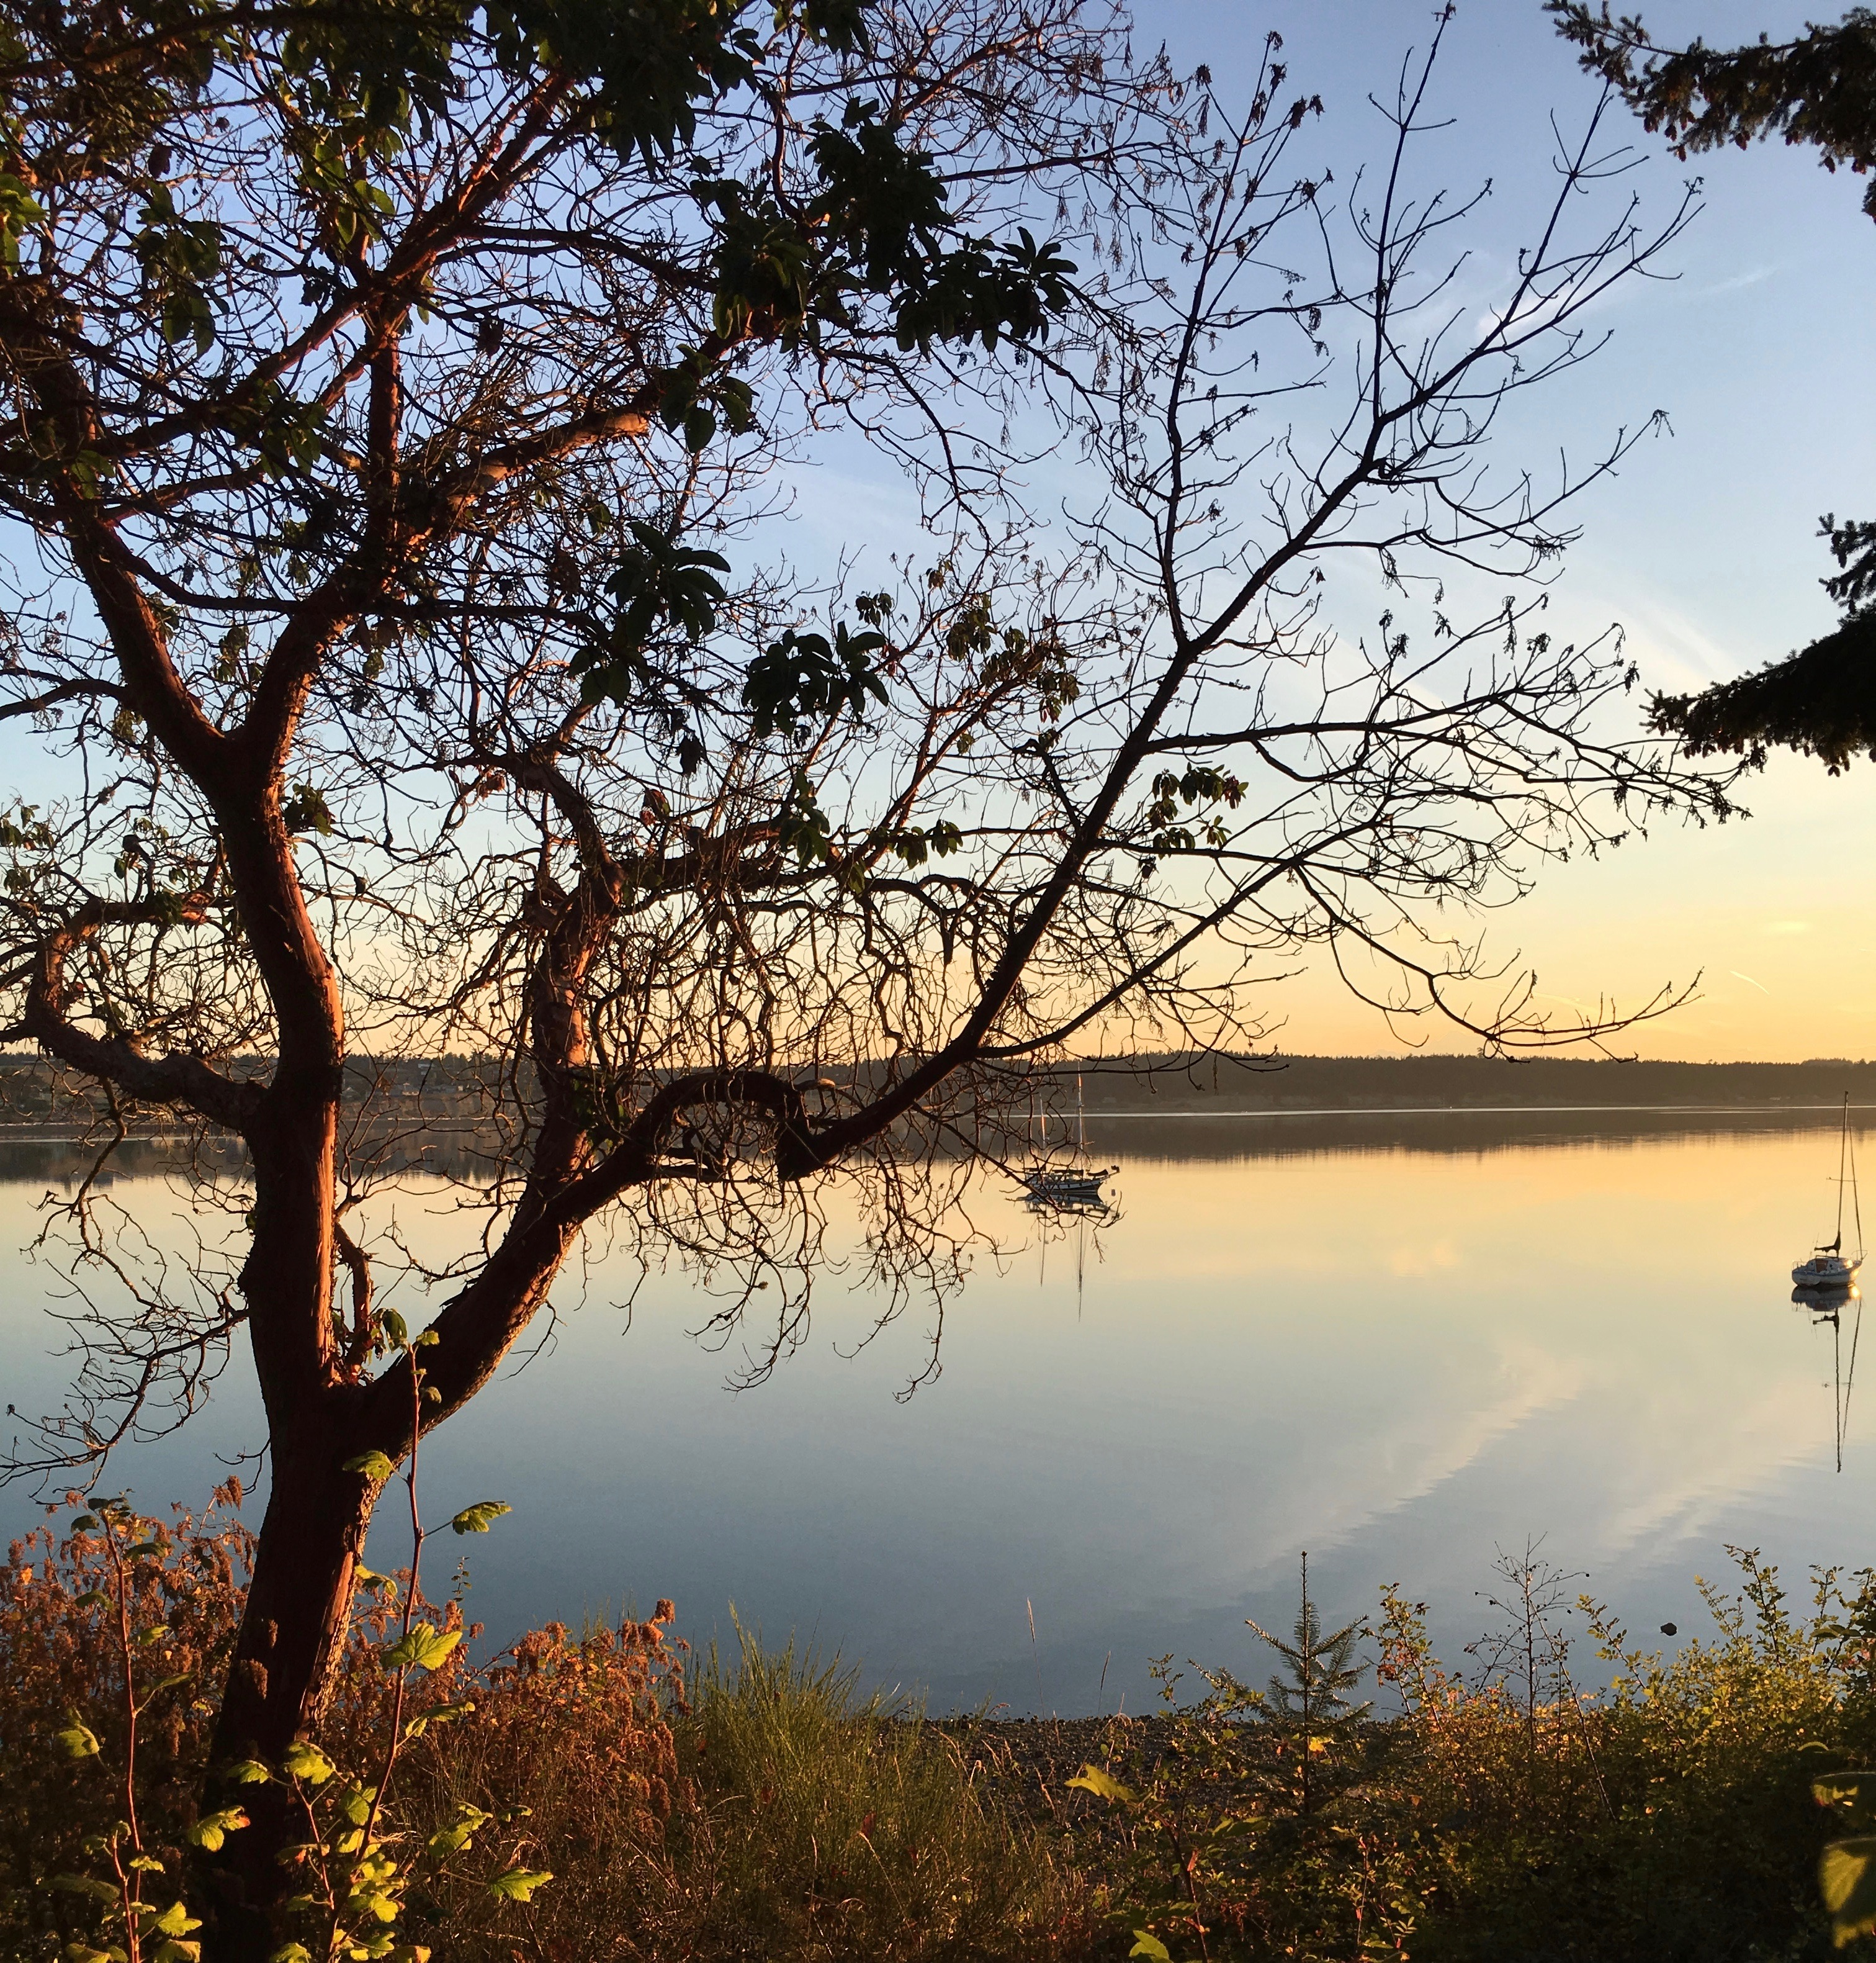
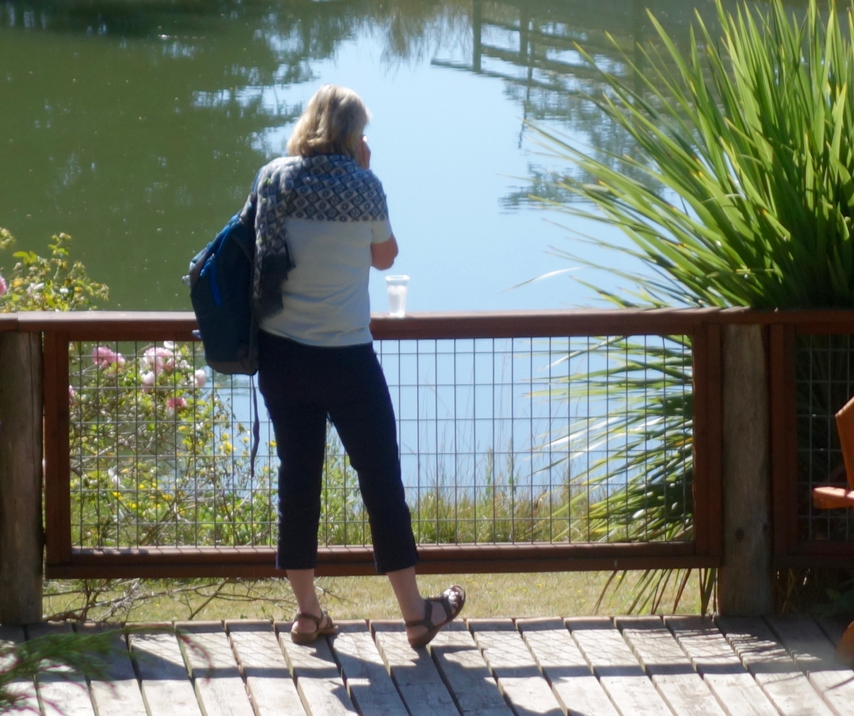

Contact Information
Questions, registration forms, payments, and other communication should be directed to:
Thomas M Brod MD 12304 Santa Monica Blvd. Suite 210, Los Angeles CA 90025
Email tbrod@ucla.edu Tel +1-310-207-3337 Fax +1-310-207-1109 www.EEGym.com

Registration Information
The enrollment fee covers tuition, room, all meals (Sunday dinner– Friday lunch), and the continuing education certificate. Transportation, alcoholic beverages, and a few recreational activities are not included.
Please note that because this Summer School is designed as not-for-profit, fees have already been cut to the lowest possible point. Unfortunately, we are not able to offer discounts for residents or students.
Our summer school will be filling the entire Captain Whidbey Inn. The historic inn has thirty-one rooms of many types (see their website at www.captainwhidbey.com). Space is limited, and preference in room assignment will go those who register earliest.
The room options are:
• Private room with shared bathroom, $2000*
• Private room with private bathroom, $2550*
An additional guest sharing private room (queen-size bed) but not participating in the program is $950.
• Shared room with shared bathroom, $2000*
* See detailed notes regarding the Inn and also Cancellation policy on page 12
Payment
A $500 deposit will reserve your place through May 31, 2017. Full payment is due by June 1, 2017. Checks in US funds should be made payable to Thomas M Brod, MD. There is a 3% service charge which we must pass on to you Credit cards (via PayPal, www.paypal.me/ThomasMBrodMD) and international bank transfer.
Cancellations before April 14, 2017 are subject to a 15% fee; April 15– June 14 are subject to a 50% fee. After June 14, there is no refund unless we are able to fill the space.

ISTDP Summer School
Five Days of ISTDP Training + Immersion Experience
Captain Whidbey Inn
Whidbey Island WA
Puget Sound, Pacific Northwest
August 13-18, 2017

Registration Form for ISTDP Summer School 2017
Fill in this form and mail (address below), fax (+1.310-207-1109), or scan and email (tbrod@ucla.edu). Payment information is on the previous page.

Name: | Degree:
License Type: | License State/Country:
License Number:
Address 1:
Address 2:
City: | State:
Zip Code: | Country:
Email Address:
Phone: | Cell Phone:

Room preference (rank in order of preference):
____ Shared room with shared bathroom, $2000 ____ Private room with shared bathroom, $2000 ____ Private room with private bathroom, $2550
____ Additional Adult $ 950
Please indicate and dietary or other special accommodations, extra guests, or other additional information/concerns:

I have read and understood the policies listed in the Summer School information brochure, including payment, deposit, and cancellation (sign below).

Signature Date

Mail to: Thomas M Brod MD
12304 Santa Monica Blvd, Suite 210
Los Angeles CA 90025

